Portfolio 4 – File Server

Faculty of Information and Communication Technologies
Swinburne University of Technology

Prepared as part of the assessment requirements for
Data Communications and Security

Please do all this work with your registered assignment team.
But, submit individually to ESP by April 28th.

Name: ID:
Other team members:

Lab Details
Tutor:
Day of Week:
Time:

Marked in your lab in
week 9, beginning May 2
Contents

Introduction 1
1. Questions 1
1.1 NAT 1
1.2 ICMP (Lab 3) 1
1.2.1 Which devices are likely to generate ICMP messages? 2
1.2.2 Provide a table of ICMP error message codes. 3
1.2.3 What is the format of an ICMP message? 3
1.2.4 Why do we need ICMPv6? 3
1.3 DNS 4
1.3.1 Run Wireshark and generate a DNS query. Paste the response as captured in Wireshark into this document. 4
1.3.2 Explain the purpose of each field in the response. 4
1.4 TCP (Lab 5) 5
1.5 UDP (Lab 5) 5
1.5.1 UDP Server 6
1.5.2 UDP Client 6
1.5.3 TCP Server 7
1.5.4 TCP Client 7
1.6 HTTP (Lab 6) 8
1.6.1 Explain, using pictures and words, how you can restrict access to all cookies when running IE7. 8
1.6.2 Explain, using pictures and words, how you can selectively restrict cookies when running Mozilla/5.0 9
2. Code 11
2.1 FileServer 11
2.2 Client 12
References: 14

Introduction

This submission has two parts.

Part one follows the usual format and includes questions relating to lectures and lab work covered during the last few weeks.

In part two, you need to cut and paste your code from work you have done on the assignment. In particular you need to show you have made significant progress towards the assignment by demonstrating working code for the file server and a client. The code your have written needs to be pasted into this document, it must be easy to read and indented. It does to need to be polished but you do need to be able to transfer a file between two physical machines. You must clearly show as a comment in your code, where your code was sources from.

You must submit your completed work to ESP by April 28th.

Your work will be marked in labs in week 9. You will need to be in the lab and be prepared to discuss your work with your tutor otherwise 0 marks will be awarded.

Questions

NAT
Explain with the aid of a diagram how NAT is achieved. Make sure you explain what details are maintained by the router and how received packets from the Internet side are sent into the intranet.
Network address translation (NAT), is a technology where a packet's header data is changed by a routing device. This is commonly used to 'hide' an address space behind a single IP, which acts as an address for the entire local network. When NAT is used in this context, all devices on a single local network appear to other hosts on the internet to have the same IP. The router, being the device bridging the local and wider networks, is responsible for managing this process, by modifying a packet's header data whenever it leaves or enters the local network.
When a device creates a packet, it contains four fields important to transmitting the packet over the internet: the source IP address, destination IP address, source port and destination port. When the packet is initially created, the destination port and IP address are those of the destination host, and the source port and IP address are those of the specific device sending the packet. If the device sending the packet is on a local network using NAT, the source IP address of the packet being sent is the local network address of the device, rather than a global address (because under NAT the device only has a local address, and not a global address).
When NAT is being used, the packet must be modified before it is sent out of the local network. If the packet were sent as-is, the source IP address (i.e. the local address of the sending device) would be used by the receiving host to send a reply packet. Because it is only a local address, it would not correspond to the original host, as intended, but would result in the packet being sent to whichever device currently has that address as its global address.
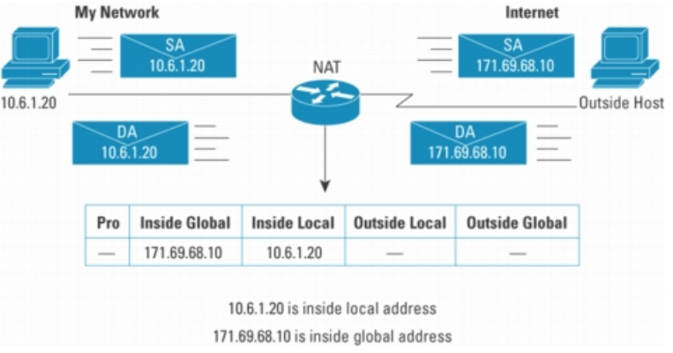
Figure 1 Network Address Translation (Cisco, 2004)
To avoid this, the router changes the source IP and source port in the packet header to the single unique global IP of the network, and the port through which the router will send the packet. Thus, when the receiving device sends a reply to the packet, it uses the network address and router port as the destination IP and port, so that the packet will be sent to the correct network. When the reply packet reaches the network, the router is responsible for changing the destination IP and port fields to values reflecting the actual destination host (i.e. the destination hosts' port, and the destination hosts' local IP address).
In order to be able to do this, the router must manage a NAT table, in which the router stores a mapping between the global and local network data for that packet. When a packet is sent out of the network, the router creates a new entry in the table, indicating the mapping between the local port and local IP address of the sending host, and the global network address and port from which the router will send the packet. When a reply packet is received by the router, it examines the destination IP address and port number (which will correspond to the network IP and router port), looks the pair up in the table, and modifies it to the correct local network data, thus ensuring the packet will reach the original sending host.

ICMP (Lab 3)

Which devices are likely to generate ICMP messages?
Devices that use IP can generate ICMP messages to send queries and error messages to each other.
Devices which are likely to send ICMPv4 messages are either hosts to query other devices, or routers to send messages on the availability of other devices. Devices using ICMPv6 will also generate similar messages, with the addition of functions such as ARP messages, a feature integrated into version 6.

Provide a table of ICMP error message codes.
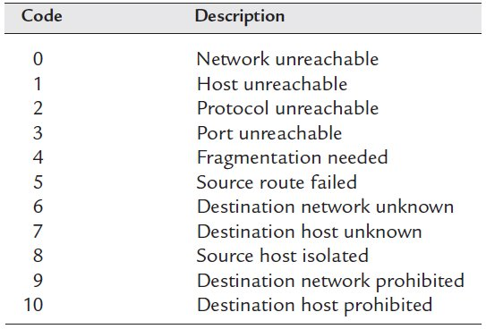
Figure 2 ICMP Error Message Codes (Embedded, 2011)

What is the format of an ICMP message?
ICMP messages follow the following general format:

Type (Bit 0 - 7): A byte-long number indicating the type of message contained within the packet. In ICMPv6, the type field is separated into two sections, the lower half of numbers (0 – 127) reserved for error message types, and the upper half (0 – 255) reserved for informational message types.

Code (Bit 8 - 15): Used to add further specification to the message type.

Checksum (Bit 16 - 31): A value used to check if errors may have occurred header during transmission. Calculated in the same manner as the IP header checksum, using the ICMP header and data.

Data (Bit 32 – 63): A four-byte field containing the ICMP data. The exact length of this field will vary depending on the ICMP message type being sent. Padding data is used to ensure this field is the appropriate length.

Why do we need ICMPv6?
With the introduction of IPv6, a number of other protocols were updated. Where some protocols were updated out of necessity, to make them ‘work’ with IPv6, others were updated to address issues making the protocol less efficient. ICMPv6 is an update of ICMPv4, made mostly to increase the efficiency of ICMP and similar protocols, by integrating them.

Structurally, while the fields of ICMPv4 and ICMPv6 are identical, the ‘type’ field is interpreted differently in ICMPv6. In both versions of the protocol, the ‘type’ field indicates what sort of message the ICMP packet contains. In ICMPv6, this meaning of this field has been ‘split’ in two, with one half of the numbers being reserved for ‘error’ message types, and the other for ‘information’ message types. This differs from ICMPv4, where the two different types of messages are not segregated for the type field.

The main benefit of ICMPv6 is that it forms a complete solution for functions previously carried out by a number of smaller protocols (ICMP, IGMP and ARP). ICMPv6 has become a multi-purpose protocol, capable of transmitting not only error messages, but packet processing, neighbour discovery and multicast reporting. The use of ICMPv6 also eliminates the use of messages with have become obsolete with the introduction of the ‘v6’ protocols.

DNS

Run Wireshark and generate a DNS query. Paste the response as captured in Wireshark into this document.
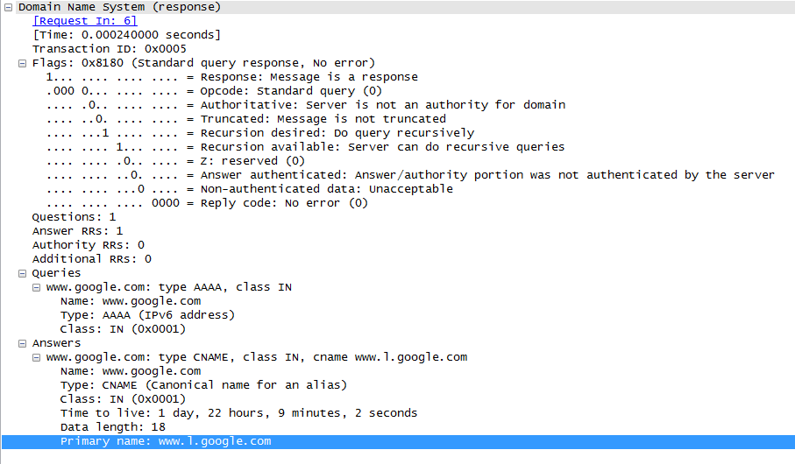
Figure 3 DNS Response

Explain the purpose of each field in the response.
Flags: The flags indicate a number of things about the packet. The flags indicate the type of packet (i.e. response/request) being sent; the type of query; the type of server which responded and other specifics.

Questions: A number indicating the number of queries that are in the packet.

Answer RRs: A number indicating the number of responses that are contained in the packet.

Authority RRs: The number of resource records in the packet that came from an authority server.

Additional RRs: The number of resource records in the packet that came from additional servers.

Queries: Contains information about the query. The field includes the domain name being queried and the type of query (i.e. A, MX) being made.

Answers: Contains the answer information regarding the query in the field above. The field indicates the type of response (e.g. CNAME) that has been sent, the ‘value’ field of the resource record, and the records time to live.

TCP (Lab 5)
Transport layer demultiplexing is required to assign received segments to the correct process. Explain in detail how this is achieved. Pay particular attendance to the need to examine IP and port numbers. (Hint, see chapter 3, Kurose Ross, Multiplexing and Demultiplexing)
Demultiplexing allows one host to have many connections to a listening server, and for multiple hosts to have a connection created with a server using one server port.
For example, when a server receives a request from host ‘1’ on a listening port, ‘X’, it will send the information to the application layer for processing. The application layer will assign another port, ‘Y’, on the server to use from now on for communication with host 1’s IP address and port number. If another request for a different transaction from the same host IP address but different port number is made, the application layer on the server will assign another different port, ‘Z’, for that transaction.

The receiving host is able to differentiate between the two connections by examining the source IP and port, and destination IP and port. For every transaction, the destination IP will be the same (as the packets are still going to the same device), but the other three fields will change based on which exact ‘link’ between the two hosts the packet is destined for.
Similarly, if another host, ‘2’, also communicated with the server on the listening port X, the server will be able to differentiate between messages from host 1 and host 2. The server will record each host’s IP address and port number for the transaction, and assign it a different port. When a packet is received, the sending host can be determined using the source IP field, which will be different even if both host 1 and 2 are transmitting to the server from the same port number.

UDP (Lab 5)
Copy and paste the UDP code from Kurose Ross (Chapter 2). Modify the code so it exchanges 5,000 messages. Print the start time and the end time at the end of the exchange. How long did it take?

The exchange of 5000 messages using UDP takes approximately 3 seconds, using the code shown below.

Repeat the same exercise for the TCP code, open a new connection for each exchange. How long did it take?

The exchange of 5000 messages using TCP takes approximately 3 seconds. If the code is modified so that the connection isn’t closed and then re-opened for each message sent, the 5000 exchanges take approximately 1 second to be sent.

Paste your code for all four parts:

UDP Server
import java.io.*;
import java.net.*;

class UDPServer
{
public static void main(String args[]) throws Exception
{
DatagramSocket serverSocket = new DatagramSocket(9876);
byte[] receiveData = new byte[1024];
byte[] sendData = new byte[1024];

while(true){
DatagramPacket receivePacket = new DatagramPacket(receiveData, receiveData.length);
serverSocket.receive(receivePacket);
String sentence = new String(receivePacket.getData());
String capitalisedSentence = sentence.toUpperCase();

InetAddress IPAddress = receivePacket.getAddress();
int port = receivePacket.getPort();
sendData = capitalisedSentence.getBytes();
DatagramPacket sendPacket = new DatagramPacket(sendData, sendData.length, IPAddress, port);
serverSocket.send(sendPacket);
}
}
}

UDP Client
import java.io.*;
import java.net.*;
import java.util.Date;

class UDPClient
{
public static void main(String args[]) throws Exception
{
Date before = new Date();
System.out.println("Start time: " + before.toString());

for(int i = 0; i < 5000; i++){
DatagramSocket clientSocket = new DatagramSocket();
InetAddress IPAddress = InetAddress.getByName("charlie-PC");
byte[] sendData = new byte[1024];
byte[] receiveData = new byte[1024];
String sentence = "teststring";
sendData = sentence.getBytes();
DatagramPacket sendPacket = new DatagramPacket(sendData, sendData.length, IPAddress, 9876);
clientSocket.send(sendPacket);
DatagramPacket receivePacket = new DatagramPacket(receiveData, receiveData.length);
clientSocket.receive(receivePacket);
String modifiedSentence = new String(receivePacket.getData());
clientSocket.close();
}

Date after = new Date();
System.out.println("End time: " + after.toString());
}
}

TCP Server
import java.io.*;
import java.net.*;

class TCPServer
{
public static void main(String argv[]) throws Exception
{
String clientSentence;
String capitalisedSentence;

ServerSocket welcomeSocket = new ServerSocket(6789);

while(true){
Socket connectionSocket = welcomeSocket.accept();
BufferedReader inFromClient = new BufferedReader(new InputStreamReader(connectionSocket.getInputStream()));
DataOutputStream outToClient = new DataOutputStream(connectionSocket.getOutputStream());

clientSentence = inFromClient.readLine();
capitalisedSentence = clientSentence.toUpperCase() + '\n';
outToClient.writeBytes(capitalisedSentence);
}
}
}

TCP Client
import java.io.*;
import java.net.*;
import java.util.Date;

class TCPClient
{
public static void main(String argv[]) throws Exception
{
String sentence = "teststring";
String modifiedSentence;
Date before = new Date();

System.out.println("Start time: " + before.toString());

for(int i = 0; i < 5000; i++){
Socket clientSocket = new Socket("charlie-PC", 6789);
DataOutputStream outToServer = new DataOutputStream(clientSocket.getOutputStream());
BufferedReader inFromServer = new BufferedReader(new InputStreamReader(clientSocket.getInputStream()));
sentence = "iAmAString";
outToServer.writeBytes(sentence + '\n');
modifiedSentence = inFromServer.readLine();
clientSocket.close();
}

Date after = new Date();
System.out.println("End time: " + after.toString());
}
}

HTTP (Lab 6)

Explain, using pictures and words, how you can restrict access to all cookies when running IE7.
To restrict access to all cookies in Internet Explorer 7:
1. Open the ‘Tools’ menu
2. Click ‘Internet Options’
3. Select the ‘privacy’ tab
4.Click on Advanced:
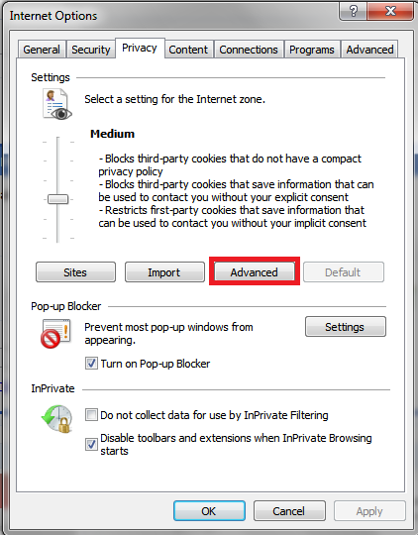
Figure 4 Internet Options - Internet Explorer
5.Tick the Override automatic cookie handling checkbox
6.Select ‘Block’ First-party Cookies and ‘Block’ Third-party Cookies
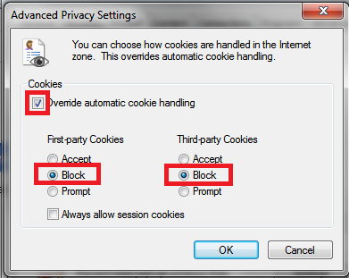
Figure 5 Advanced Privacy Settings - Internet Explorer
7.Click ‘OK’

Explain, using pictures and words, how you can selectively restrict cookies when running Mozilla/5.0
To restrict access to cookies in Mozilla Firefox 4:
1.Click the Firefox button
2.Select options and click Options
3.Select the Privacy tab:
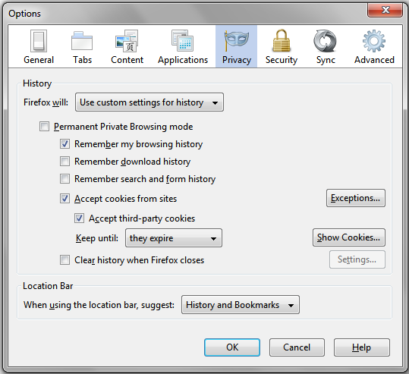
Figure 6 Privacy Tab - Firefox
4. Uncheck the ‘Accept cookies from sites’ checkbox

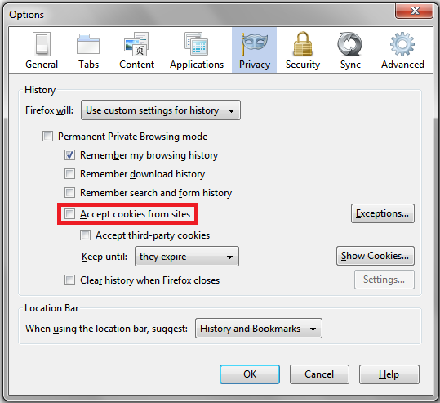
Figure 7 Privacy Tab - Firefox
5. Click ‘OK’

Code

FileServer
import java.io.*;
import java.net.*;

public class FileServer implements Runnable
{
private static final int LISTENING_PORT = 2011;
private static final int BUFFER_SIZE = 1024;
private static final int EOF = -1;

private Socket connectedSocket;
private BufferedReader inFromClient;
private DataOutputStream outToClient;

public FileServer(Socket aConnectedSocket)
{
connectedSocket = aConnectedSocket;
//Set up input/output streams
try
{
inFromClient = new BufferedReader(new InputStreamReader(connectedSocket.getInputStream()));
outToClient = new DataOutputStream(connectedSocket.getOutputStream());
}
catch(Exception e)
{
System.out.println(e);
}
}

public static void main(String[] args) throws Exception
{
ServerSocket listenSocket = new ServerSocket(LISTENING_PORT);
System.out.println("Listening on port 2011");

while(true){
//Set up connection - create new thread when client connects
new Thread(new FileServer(listenSocket.accept())).start();
}
}

public void run()
{
System.out.println("Client connected!");

try
{
//Get name of file to send
String fileToSend = inFromClient.readLine();

//Send Specified file if it exists, otherwise send message to client and get name of file again
File sendFile = new File(fileToSend);
byte[] fileBuffer = new byte[BUFFER_SIZE];
InputStream fileReader = new BufferedInputStream(new FileInputStream(sendFile));
int bytesRead;
while((bytesRead = fileReader.read(fileBuffer)) != EOF){
outToClient.write(fileBuffer, 0, bytesRead);
}

connectedSocket.close();
}
catch(FileNotFoundException e)
{
System.out.println("Invalid file specified - sending try again message");
try
{
outToClient.writeBytes("invalid" + '\n');
}
catch(IOException ioe)
{
System.out.println("Error sending message - close client manually");
}
run();
}
catch(SocketException e)
{
System.out.println("Client disconnected early - closing connection!");
}
catch(IOException e)
{
System.out.println("Error reading from client - closing connection");
}

System.out.println("Client disconnected!");
}
}

Client
import java.io.*;
import java.net.*;

public class Client
{
private static final int BUFFER_SIZE = 1024;
private static final int EOF = -1;

public static void main(String[] args) throws Exception
{
BufferedReader inFromUser = new BufferedReader(new InputStreamReader(System.in));

//Set up connection
Socket clientSocket = new Socket("charlie-PC", 2011);
DataOutputStream outToServer = new DataOutputStream(clientSocket.getOutputStream());
BufferedInputStream inFromServer = new BufferedInputStream(clientSocket.getInputStream());

String errorMessage; //set up variable to store possible error message
do{
//Specify file to transfer
System.out.print("Specify a file: ");
String fileName = inFromUser.readLine();
outToServer.writeBytes(fileName + '\n');

//Receive possible 'invalid file' error message
byte[] temp = new byte[BUFFER_SIZE];
inFromServer.read(temp);
errorMessage = new String(temp).trim();
System.out.println("MESSAGE: '" + errorMessage + "'");

//if invalid file, loop again, if not, ask for save file name and save the file being transmitted
if(!errorMessage.equals("invalid")){
//Get filename to save to
System.out.print("Save as: ");
String newFileName = inFromUser.readLine();

//Open and write to file
try
{
byte[] fileBuffer = new byte[BUFFER_SIZE];
BufferedOutputStream fileWriter = new BufferedOutputStream(new FileOutputStream(newFileName));
//write bytes read in case of error message to the file
fileWriter.write(temp);
while(inFromServer.read(fileBuffer) != EOF){
fileWriter.write(fileBuffer);
}
fileWriter.close();
}
catch(NullPointerException e)
{
System.out.println("New filename not specified!");
}
}
}while(errorMessage.equals("invalid"));

clientSocket.close();
System.out.println("Disconnected!");
}
}

References:
Cisco, 2004, Viewed April 24 2011, Network Address Translation <http://www.cisco.com/en/US/technologies/tk648/tk361/tk438/technologies_white_paper09186a0080091cb9.html>
Embedded.com, 2011, Viewed April 26 2011, ‘TCP/IP Embedded Internet Applications - The Network Layer, Part 2: IPv6, ICMP and UDP’
<http://vault.embedded.com/design/224700901?pgno=2>
Javvin, Date Unknown, Viewed April 26 2011, Internet Message Control Protocol, <http://www.javvin.com/protocolICMP.html>
Slideshare, 2009, Viewed April 26 2011, ICMPv4 and ICMPv6, <http://www.slideshare.net/engineerrd/icmp-v4-and-icmp-v6>
IPv6, 2008, Viewed April 26 2011, What is ICMPv6?, <http://ipv6.com/articles/general/ICMPv6.htm>

